# Chapter 4 Loops

Problem 1. Budgeted vs. Actual Expenses

Write program that asks the user to enter the amount that he or she has budgeted for a month. Using a while loop, the user should be prompted to enter each of his or her expenses for the month and keep a running total. When the loop finishes, the program should display the amount that the user is over or under budget.

**Design.** Use an IPO diagram to design your program. See IPO diagram attached to this assignment.

**Code.** Write your program in Python using the above steps. Save your program as a .py file with the name *yourlastname*_Lab4.1.py

**Output.** Your program should produce correctly labeled output with dollar amounts rounded to 2 decimal places and dollar signs. Sample dialog:

Enter amount budgeted for the month: 500

Enter an amount spent(0 to quit): 50

Enter an amount spent(0 to quit): 75

Enter an amount spent(0 to quit): 800

Enter an amount spent(0 to quit): 23.95

Enter an amount spent(0 to quit): 0

Budgeted: $ 500.00

Spent: $ 948.95

You are $ 448.95 over budget. PLAN BETTER NEXT TIME!

monthly_expense_item_amount

monthly_expense_item_amount

monthly_expense_item_amount

over_budget_amount

over_budget_amount

over_under_budget_amount

over_under_budget_amount

over_under_budget_amount

over_under_budget_amount

over_under_budget_amount == 0:

over_under_budget_amount > 0:

running_total_expense_spent

running_total_expense_spent

running_total_expense_spent

running_total_expense_spent

total_monthly_budget_amount

total_monthly_budget_amount

total_monthly_budget_amount

Problem 2. Ocean Levels

Assuming the ocean’s level is currently rising at about 1.8 millimeters per year, create an application that displays the number of millimeters that the ocean will have risen each year for the next 25 years.

**Design.** Use an IPO diagram to design your program. See IPO diagram attached to this assignment.

**Code.** Write your program in Python using the above steps. Save your program as a .py file with the name *yourlastname*_Lab4.2.py

**Output.** Your program output should look something like this:

Year Rise (in millimeters)

------------------------------------------

1 1.80

2 3.60

3 5.40

4 7.20

5 9.00

6 10.80

7 12.60

8 14.40

9 16.20

10 18.00

11 19.80

12 21.60

13 23.40

14 25.20

15 27.00

16 28.80

17 30.60

18 32.40

19 34.20

20 36.00

21 37.80

22 39.60

23 41.40

24 43.20

25 45.00

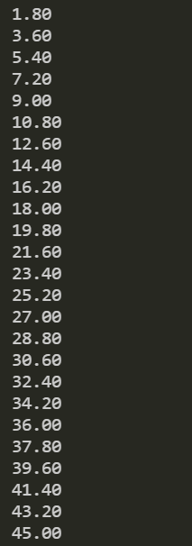

**Programming Style Requirements.**

Comments – Begin your program with a comment that includes: a) your name, b)program status – either “Complete” or describe any incomplete or non-functioning part of your program c)A 1-3 line description of what the program does.

Variable names – use meaningful variable names such as total_taxes or num_cookies.

Named constants – Use named constants for all number values that will not be changed in the program such as RECIPE_SUGAR = 1.5. See section 2.9 on Named Constants

You will have two .py files and one IPO file to turn in to Blackboard.